TITLE OF THE PAPER (STYLE HEADING 1: FONT FORMATS – TIMES NEW ROMAN, 14 PT BOLD, ALL CAPS; PARAGRAPH FORMATS: CENTERED, SPACING BEFORE 30 PT, SPACING AFTER 0 PT, KEEP WITH NEXT, KEEP LINES TOGETHER)

Author(s)
(Style Heading 2: 13pt bold, title case, centered, spacing before 0 pt, spacing after 15 pt, keep with next, keep lines together)
Affiliation
(Style Affiliation: 12pt, italic, centered, spacing before 0 pt, after 18 pt, keep with next)

Abstract (bold). Short abstract (Style Abstract:10 pt, italic, spacing after 6 pt, justified, 1 cm left and right indentation).
Key words (bold): key word 1, key word 2, key word 3... to (max) key word 5.

1. Main Heading (Style Heading 3: Small Caps 12 pt, Centered, Spacing before 24 pt, Spacing after 12 pt, Keep with Next, Keep Lines Together)
Main text: only use characters and symbols available in the Times New Roman, (Style Main Text: 11 pt; paragraph format: left alignment, left and right indent 0 pt, space before and after 0 pt, first line indent 0.5 cm).

1.1. Subheading (Style Subheading 2: 11 pt, bold, center alignment,
spacing before 12 pt, after 12 pt, keep with next, keep lines together)
Main text: only use characters and symbols available in the Times New Roman, (Style Main Text: 11 pt; paragraph format: left alignment, left and right indent 0 pt, space before and after 0 pt, first line indent 0.5 cm).
1.1.1. Subheading (Style Subheading 2: 11 pt, italic, left, indentation left 5 pt,
spacing before 12 pt, after 12pt, keep with next, keep lines together)
Main text: only use characters and symbols available in the Times New Roman, (Style Main Text: 11 pt; paragraph format: left alignment, left and right indent 0 pt, space before and after 0 pt, first line indent 0.5 cm).

Tables & figures (if needed)
Table 1. Title (font format: 11pt,; paragraph format:
center alignment, left and right indent 0 pt, space before and after 0 pt)
Properties 1 | Properties 2 | Properties 3 and, etc.
Variable | Variable | Variable
Variable | Variable | Variable
Caption

Figure 1. Title (font format: 11pt,; paragraph format:
center alignment, left and right indent 0 pt, space before and after 0)
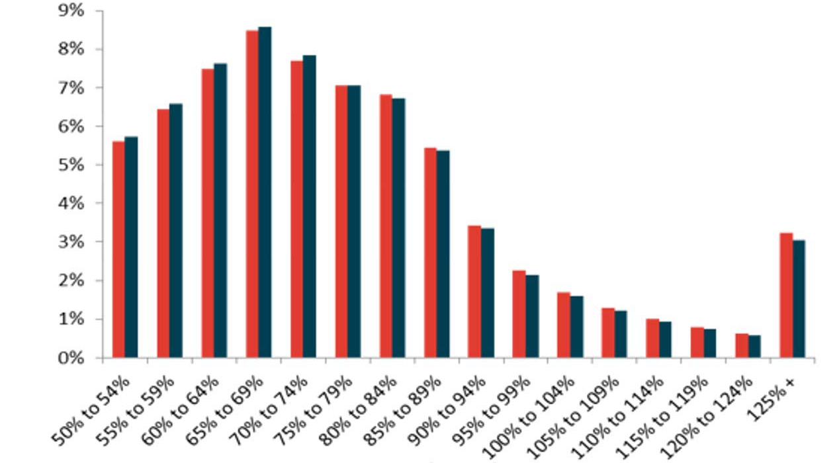

References
Books
Book with one author (print edition)
Bourdieu, P. (1998). On Television. New York: The New Press.

Book with one author (electronic edition)
Anderson, C.A., Gentile, D.A., & Buckley, K.E. (2007). Violent Video Game Effects on Children and Adolescents: Theory, Research and Public Policy. doi:10.1093/acprof:oso/9780195309836.001.0001

Two or more works by the same author
Latour, B. (2005). Reassembling the Social. An Introduction to Actor-Network-Theory. New York: Oxford University Press.
Latour, B. (2013). An Inquiry into Modes of Existence: An Anthropology of the Moderns. Cambridge, Massachusetts: Hardvard University Press.
McLuhan, M. (1970a). Culture is Our Business. New York, NY: McGraw-Hill.
McLuhan, M. (1970b). From Cliché to Archetype. New York, NY: Viking Press.

Work with two or more authors
Hoskins, A., & OʹLoughlin, B. (2007). Television and Terror: Conflicting Times and the Crisis of News Discourse. New York: Palgrave MacMillan.

Book by a corporate author
American Psychological Association. (1972). Ethical Standards of Psychologists. Washington, DC: American Psychological Association.

Edition, anthology or compilation
Neiger, M., Meyers, O., & Zandberg, E. (Eds.). (2011). On Media Memory: Collective Memory in a New Media Age. Basingstoke-New York: Palgrave Macmillian.

Work in an edition, anthology or an essay in a book
Reading, A. (2011). Memory and Digital Media: Six Dynamics of the Globital Memory Field. In Neiger, M., Meyers, O., & Zandberg, E. (Eds.), On Media Memory: Collective Memory in a New Media Age (pp.241-252), Basingstoke-New York: Palgrave Macmillian.

Work in a dictionary
Protest, v. (1971). Compact Edition of the Oxford English Dictionary (Vol. 2, p. 2335). Oxford: Oxford University Press.

Article in a reference book or an entry in an encyclopedia
Guignon, C. B. (1998). Existentialism. In E. Craig (Ed.), Routledge Encyclopedia of Philosophy (Vol. 3, pp. 493-502). London, England: Routledge.

Articles
Article in a journal (print edition)
Rector , L. H . (2008). Comparison of Wikipedia and Other Encyclopedias for Accuracy, Breadth, and Depth in Historical Articles. RSR. Reference Services Review, 36 ( 1 ), 7-22 .

Article in a journal (electronic edition)
Rosenzweig , R. (2006). Can History Be Open Source? Wikipedia and the Future of the Past. Journal of American History, 93 (1), 117–146. https://doi.org/10.2307/4486062.
If there is no DOI for an article found in an online periodical, include the URL for the journal home page.
Cooper, A., & Humphreys, K. (2008). The Uncertainty Is Killing Me: Self-triage Decision Making and Information Availability. E-Journal of Applied Psychology, 4(1). Retrieved from http://ojs.lib.swin.edu.au/index.php/ejap/

Article in a newspaper or magazine
Semenak, S. (1995, December 28). Feeling Right at Home: Government Residence Eschews Traditional Rules. Montreal Gazette, p. A4.
Driedger, S. D. (1998, April 20). After Divorce. Maclean's, 111(16), 38-43.

Multimedia

Television or radio program
MacIntyre, L. (Reporter). (2002, January 23). Scandal of the Century [Television series episode]. In H. Cashore (Producer), The fifth estate. Toronto, Canada: Canadian Broadcasting Corporation.

Film, videorecording or DVD
Kubrick, S. (Director). (1980). The Shining [Motion picture]. United States: Warner Brothers.

YouTube videos
Apsolon, M. [markapsolon]. (2011, September 9). Real ghost girl caught on Video Tape 14 [Video file]. Retrieved from http://www.youtube.com/watch?v=6nyGCbxD848

Web pages & non-periodical documents on the Internet
Library and Archives Canada. (2008). Celebrating women's achievements: Women artists in Canada. Retrieved from http://www.collectionscanada.gc.ca/women/002026-500-e.html

naslov rada (STYLE HEADING 1: FONT FORMATS – TIMES NEW ROMAN, 14 PT BOLD, ALL CAPS; PARAGRAPH FORMATS: CENTERED, SPACING BEFORE 30 PT, SPACING AFTER 0 PT, KEEP WITH NEXT, KEEP LINES TOGETHER)

Autor(i)
(Style Heading 2: 13pt bold, title case, centered, spacing before 0 pt, spacing after 15 pt, keep with next, keep lines together)
Afilijacija
(Style Affiliation: 12pt, italic, centered, spacing before 0 pt, after 18 pt, keep with next)

Sažetak (bold). Short abstract (Style Abstract:10 pt, italic, spacing after 6 pt, justified, 1 cm left and right indentation).
Ključne riječi (bold): key word 1, key word 2, key word 3... to (max) key word 5.

